**Intelligent Admissions: The Future of University Decision Making with Machine Learning**

## ABSTRACT:

During recent years, universities have become more and more dependent on the collection, storage and processing of

educational data. The dynamics and transformation of military higher education, characterized by complex processes and

statuses, generate an immense volume of data, and their acquisition and storage requires the use of the innovation in the IT

field. In this context, these universities have become more and more dependent on the collection, storage and processing of

educational data. Decision-makers try to apply new strategies and use new tools to convert this data in useful information that

would contribute to managerial problem solving. Good decisions involve using some software tools that support decision-

making process to maximize the performance of universities and minimize the negative impact of faults. In this paper, we

present an overview of intelligent decision support systems (iDSS), and also our own conceptual model in designing a higher

educationiDSS. The proposed system will be composed of three subsystems working in an integrated manner in order to

provide quality services to the iDSS beneficiaries, as follows: the Data Management Subsystem (DMS) that offers the

necessary data in order to develop of iDSS models, the Model Management Subsystem (MMS) which generates models on

the basis of the data supplied by the DMS and the use of data mining techniques, analytic tools and reporting, the user

interface (UI) this facilitates communication between iDSS and the beneficiary, in the sense that the beneficiary supplies the

iDSS with data and extracts useful information for the educational process. educational data. The dynamics and transformation of military higher education, characterized by complex processes and

statuses, generate an immense volume of data, and their acquisition and storage requires the use of the innovation in the IT

field. In this context, these universities have become more and more dependent on the collection, storage and processing of

educational data. Decision-makers try to apply new strategies and use new tools to convert this data in useful information that

would contribute to managerial problem solving. Good decisions involve using some software tools that support decision-

making process to maximize the performance of universities and minimize the negative impact of faults. In this paper, we

present an overview of intelligent decision support systems (iDSS), and also our own conceptual model in designing a higher

educationiDSS. The proposed system will be composed of three subsystems working in an integrated manner in order to

provide quality services to the iDSS beneficiaries, as follows: the Data Management Subsystem (DMS) that offers the

necessary data in order to develop of iDSS models, the Model Management Subsystem (MMS) which generates models on

the basis of the data supplied by the DMS and the use of data mining techniques, analytic tools and reporting, the user

interface (UI) this facilitates communication between iDSS and the beneficiary, in the sense that the beneficiary supplies the

iDSS with data and extracts useful information for the educational process.

# During recent years, universities have become more and more dependent on the collection, storage and processing of educational data. The dynamics and transformation of military higher education, characterized by complex processes and statuses, generate an immense volume of data, and their acquisition and storage requires the use of the innovation in the IT field. In this context, these universities have become more and more dependent on the collection, storage and processing of educational data. Decision-makers try to apply new strategies and use new tools to convert this data in useful information that would contribute to managerial problem solving. Good decisions involve using some software tools that support decision-making process to maximize the performance of universities and minimize the negative impact of faults. In this paper, we present an overview of intelligent decision support systems (iDSS), and also our own conceptual model in designing a higher education iDSS. The proposed system will be composed of three subsystems working in an integrated manner in order to provide quality services to the iDSS beneficiaries, as follows: the Data Management Subsystem (DMS) that offers the necessary data in order to develop of iDSS models, the Model Management Subsystem (MMS) which generates models on the basis of the data supplied by the DMS and the use of data mining techniques, analytic tools and reporting, the user interface (UI) this facilitates communication between iDSS and the beneficiary, in the sense that the beneficiary supplies the iDSS with data and extracts useful information for the educational process.

**PURPOSE STATEMENT:**

# The purpose of university education is to facilitate the advancement of knowledge and the development of high cognitive skills in the community. As a result, people become productive members of society who care about the well-being of others. The ability to articulate thoughts clearly is critical because it improves labor relations, which leads to improved market outcomes. It is vital to note that enlightened members of society often have a higher standard of living than individuals without the know-how required to thrive in a competitive environment.

# University education has evolved to meet the needs of an involved global community. It prepares individuals to deal with a variety of challenges by equipping them with problem-solving skills. In addition, they learn how to be influential leaders, adaptable professionals, and valuable members of society who appreciate diversity. It is important to note that graduates gain the prowess required to excel in their desired fields of practice, which allows them to make a living and lead a decent life. Institutions of higher learning prepare individuals to live in a constantly changing environment while being true to their core identities.

**PROBLEM DEFINING & DESIGN THINKING:**

# EMPHATHY MAP:

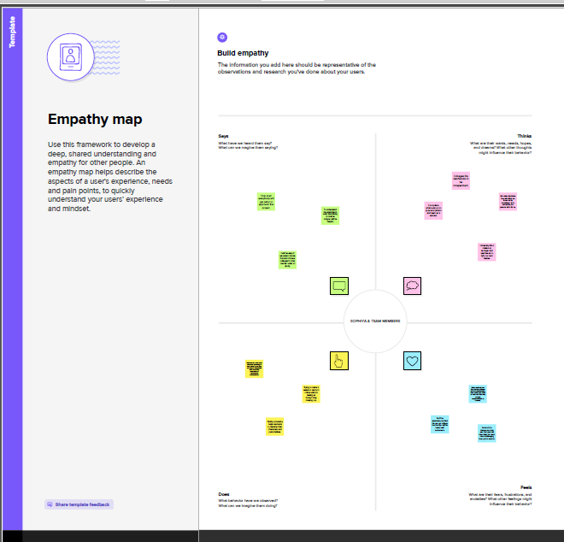

# IDEATION & BRAINSTORMING MAP:

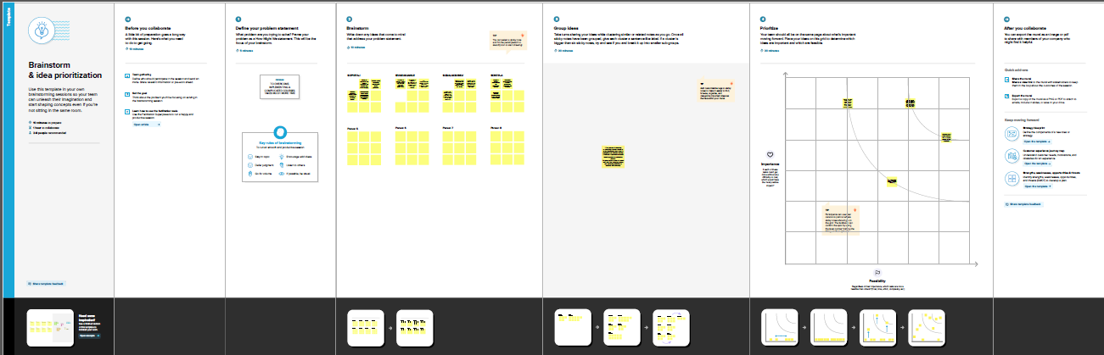

**RESULT:**

* **Universities are essential to provide learning spaces for students to plan and implement their ideas to contribute to achieve sustainable development goals and to integrate these issues into curricula and extra-curricular activities.**
* **Through quality education, people acquire the ability to listen, critically reflect about reality, and make informed choices about their life.**
* **It also provide knowledge about the latest technology used in developing the application that will be great demand in future This will provide better opportunities and guidance in future in developing projects independently.**

## ADVANTAGES OF ADMISSION PREDICT:

## The university education exposes students to new research and technology.

## Studying at university encourage creative and independent thought.

## Studying is the most basic knowledge that is to be acquired by every individual to learn various other things.

## A university education will help the student succeed in today's workforce and establish an enjoyable career of their choice.

During recent years, universities have become more and more dependent on the collection, storage and processing of

educational data. The dynamics and transformation of military higher education, characterized by complex processes and

statuses, generate an immense volume of data, and their acquisition and storage requires the use of the innovation in the IT

field. In this context, these universities have become more and more dependent on the collection, storage and processing of

educational data. Decision-makers try to apply new strategies and use new tools to convert this data in useful information that

would contribute to managerial problem solving. Good decisions involve using some software tools that support decision-

making process to maximize the performance of universities and minimize the negative impact of faults. In this paper, we

present an overview of intelligent decision support systems (iDSS), and also our own conceptual model in designing a higher

educationiDSS. The proposed system will be composed of three subsystems working in an integrated manner in order to

provide quality services to the iDSS beneficiaries, as follows: the Data Management Subsystem (DMS) that offers the

necessary data in order to develop of iDSS models, the Model Management Subsystem (MMS) which generates models on

the basis of the data supplied by the DMS and the use of data mining techniques, analytic tools and reporting, the user

interface (UI) this facilitates communication between iDSS and the beneficiary, in the sense that the beneficiary supplies the

iDSS with data and extracts useful information for the educational process.

During recent years, universities have become more and more dependent on the collection, storage and processing of

educational data. The dynamics and transformation of military higher education, characterized by complex processes and

statuses, generate an immense volume of data, and their acquisition and storage requires the use of the innovation in the IT

field. In this context, these universities have become more and more dependent on the collection, storage and processing of

educational data. Decision-makers try to apply new strategies and use new tools to convert this data in useful information that

would contribute to managerial problem solving. Good decisions involve using some software tools that support decision-

making process to maximize the performance of universities and minimize the negative impact of faults. In this paper, we

present an overview of intelligent decision support systems (iDSS), and also our own conceptual model in designing a higher

educationiDSS. The proposed system will be composed of three subsystems working in an integrated manner in order to

provide quality services to the iDSS beneficiaries, as follows: the Data Management Subsystem (DMS) that offers the

necessary data in order to develop of iDSS models, the Model Management Subsystem (MMS) which generates models on

the basis of the data supplied by the DMS and the use of data mining techniques, analytic tools and reporting, the user

interface (UI) this facilitates communication between iDSS and the beneficiary, in the sense that the beneficiary supplies the

iDSS with data and extracts useful information for the educational process.

During recent years, universities have become more and more dependent on the collection, storage and processing of

educational data. The dynamics and transformation of military higher education, characterized by complex processes and

statuses, generate an immense volume of data, and their acquisition and storage requires the use of the innovation in the IT

field. In this context, these universities have become more and more dependent on the collection, storage and processing of

educational data. Decision-makers try to apply new strategies and use new tools to convert this data in useful information that

would contribute to managerial problem solving. Good decisions involve using some software tools that support decision-

making process to maximize the performance of universities and minimize the negative impact of faults. In this paper, we

present an overview of intelligent decision support systems (iDSS), and also our own conceptual model in designing a higher

educationiDSS. The proposed system will be composed of three subsystems working in an integrated manner in order to

provide quality services to the iDSS beneficiaries, as follows: the Data Management Subsystem (DMS) that offers the

necessary data in order to develop of iDSS models, the Model Management Subsystem (MMS) which generates models on

the basis of the data supplied by the DMS and the use of data mining techniques, analytic tools and reporting, the user

interface (UI) this facilitates communication between iDSS and the beneficiary, in the sense that the beneficiary supplies the

iDSS with data and extracts useful information for the educational process.

During recent years, universities have become more and more dependent on the collection, storage and processing of

educational data. The dynamics and transformation of military higher education, characterized by complex processes and

statuses, generate an immense volume of data, and their acquisition and storage requires the use of the innovation in the IT

field. In this context, these universities have become more and more dependent on the collection, storage and processing of

educational data. Decision-makers try to apply new strategies and use new tools to convert this data in useful information that

would contribute to managerial problem solving. Good decisions involve using some software tools that support decision-

making process to maximize the performance of universities and minimize the negative impact of faults. In this paper, we

present an overview of intelligent decision support systems (iDSS), and also our own conceptual model in designing a higher

educationiDSS. The proposed system will be composed of three subsystems working in an integrated manner in order to

provide quality services to the iDSS beneficiaries, as follows: the Data Management Subsystem (DMS) that offers the

necessary data in order to develop of iDSS models, the Model Management Subsystem (MMS) which generates models on

the basis of the data supplied by the DMS and the use of data mining techniques, analytic tools and reporting, the user

interface (UI) this facilitates communication between iDSS and the beneficiary, in the sense that the beneficiary supplies the

iDSS with data and extracts useful information for the educational process.

During recent years, universities have become more and more dependent on the collection, storage and processing of

educational data. The dynamics and transformation of military higher education, characterized by complex processes and

statuses, generate an immense volume of data, and their acquisition and storage requires the use of the innovation in the IT

field. In this context, these universities have become more and more dependent on the collection, storage and processing of

educational data. Decision-makers try to apply new strategies and use new tools to convert this data in useful information that

would contribute to managerial problem solving. Good decisions involve using some software tools that support decision-

making process to maximize the performance of universities and minimize the negative impact of faults. In this paper, we

present an overview of intelligent decision support systems (iDSS), and also our own conceptual model in designing a higher

educationiDSS. The proposed system will be composed of three subsystems working in an integrated manner in order to

provide quality services to the iDSS beneficiaries, as follows: the Data Management Subsystem (DMS) that offers the

necessary data in order to develop of iDSS models, the Model Management Subsystem (MMS) which generates models on

the basis of the data supplied by the DMS and the use of data mining techniques, analytic tools and reporting, the user

interface (UI) this facilitates communication between iDSS and the beneficiary, in the sense that the beneficiary supplies the

iDSS with data and extracts useful information for the educational process.

During recent years, universities have become more and more dependent on the collection, storage and processing of

educational data. The dynamics and transformation of military higher education, characterized by complex processes and

statuses, generate an immense volume of data, and their acquisition and storage requires the use of the innovation in the IT

field. In this context, these universities have become more and more dependent on the collection, storage and processing of

educational data. Decision-makers try to apply new strategies and use new tools to convert this data in useful information that

would contribute to managerial problem solving. Good decisions involve using some software tools that support decision-

making process to maximize the performance of universities and minimize the negative impact of faults. In this paper, we

present an overview of intelligent decision support systems (iDSS), and also our own conceptual model in designing a higher

educationiDSS. The proposed system will be composed of three subsystems working in an integrated manner in order to

provide quality services to the iDSS beneficiaries, as follows: the Data Management Subsystem (DMS) that offers the

necessary data in order to develop of iDSS models, the Model Management Subsystem (MMS) which generates models on

the basis of the data supplied by the DMS and the use of data mining techniques, analytic tools and reporting, the user

interface (UI) this facilitates communication between iDSS and the beneficiary, in the sense that the beneficiary supplies the

iDSS with data and extracts useful information for the educational process.

## DISADVANTAGES OF ADMISSION PREDICT:

## The main disadvantage of universities is the lack of individual attention. Classes may have more than a hundred students, making it difficult to stand out. For the same reason, It's difficult to find student opportunities for college.

## It does not follow a proper schedule or a timespan.

## An unprofessional and non-standard education system may also cause wastage of time and money.

## Sometimes, brilliant student get bored because of the long tenure of academic sessions.

## APPLICATIONS FOR ADMISSION PREDICT:

# The university education function is to train people,and the university is a place to do just that. The special characteristics of university education are mainly manifested in the specificity of tasks.

# It is right to note that university education is institutionalized education and has a strict organizational structure and system.

# One of the aims of education is to have an influence on people’s purpose, organization, and planning. University education embodies all the characteristics of education.

# Nowadays studies in university are the huge improvement of the youngsters for their future and this is popular in every country.

# University graduates gain professional qualifications that are recognised and respected worldwide.

# University life exposes students to other culture and background.

# The ability to accurately predict the chances of university admission can help students make more informed decisions about which universities to apply to, increasing their chances of being admitted and ultimately gaining access to higher education.

## CONCLUSION:

### The future university system which capable of storing university resources such as students and staff of the university and their relationship was implemented.

### The system supports different platforms and different languages.

### It is easy to track the relations of students and courses they have taken, courses teacher they are given by using the friendly interface of the system.

## FUTURE SCOPE:

# The future scope of university for the student creating of new knowledge and presentation of past experience.

# Future university scope helps students come out of their weakness into their strength. Campus life is beyond the infrastructural and academic training programs. It enriches students with a once in a life time opportunity to live through the experiences that otherwise is earned very hard.

# Students are given the chance to travel and experience life overseas through study abroad programs.

# A college education teaches discipline to a student.They understand the importance of go through a comprehensive learning. Attending a college paves the way for a better career.

# The future universities have stable educational places, stable educational objects, and stable educational contents, as well as stable educational order and so on. This kind of stability in universities is very conductive to personal development.

**Appendix**

# Source code:

## Milestone2

import numpy as np

import pandas as pd

import matplotlib.pyplot as plt

import seaborn as sns

%matplotlib inline

data = pd.read_csv('/content/Admission_Predict.csv')

data.info()

Data columns (total 9 columns):

# Column Non-Null Count Dtype

--- ------ -------------- -----

0 Serial No. 400 non-null int64

1 GRE Score 400 non-null int64

2 TOEFL Score 400 non-null int64

3 University Rating 400 non-null int64

4 SOP 400 non-null float64

5 LOR 400 non-null float64

6 CGPA 400 non-null float64

7 Research 400 non-null int64

8 Chance of Admit 400 non-null float64

dtypes: float64(4), int64(5)

data.isnull().any()

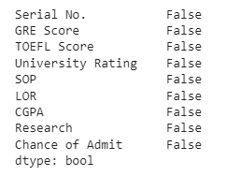

data=data.rename(columns = {'Chance of Admit ':'Chance of Admit'})

## Milestone 3

data.describe()

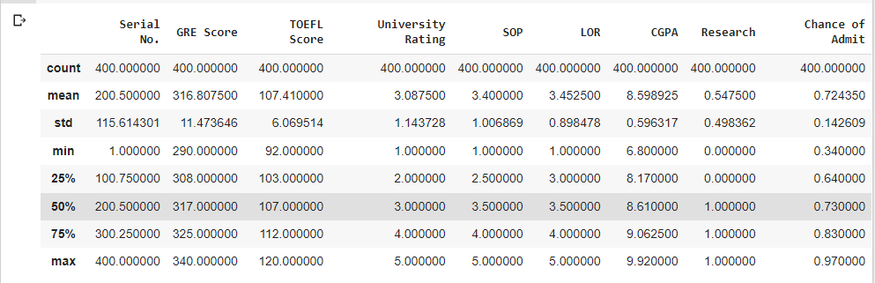

sns.distplot(data['GRE Score'])

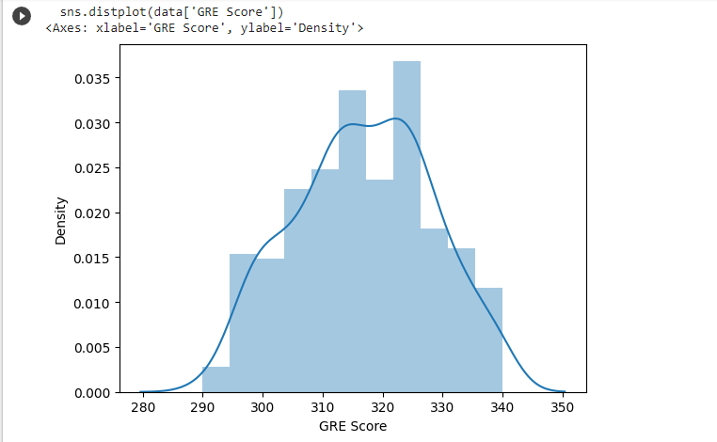

sns.heatmap(data.corr())

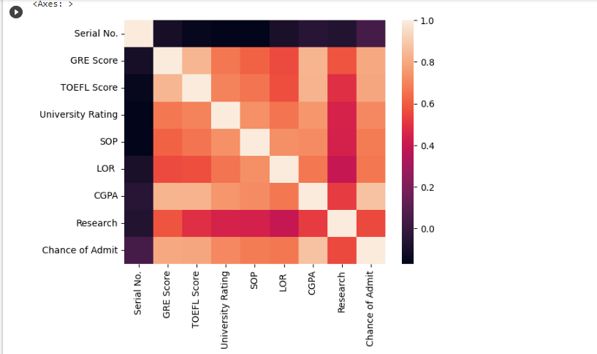

sns.pairplot(data=data,hue='Research',markers=["^","v"],palette='inferno')

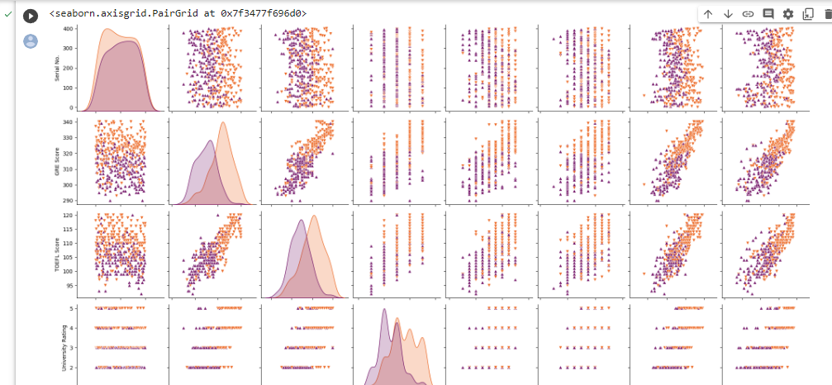

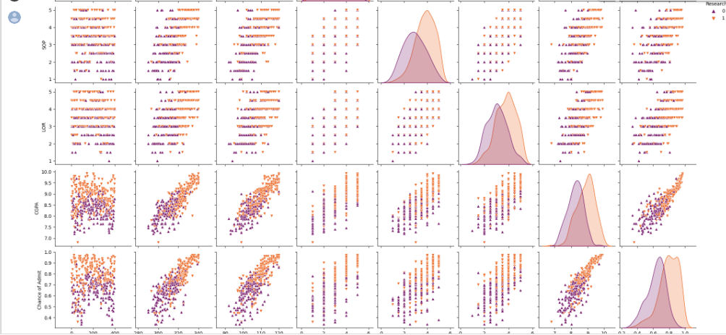

sns.scatterplot(x='University Rating',y='CGPA',data=data,color='Red', s=100)

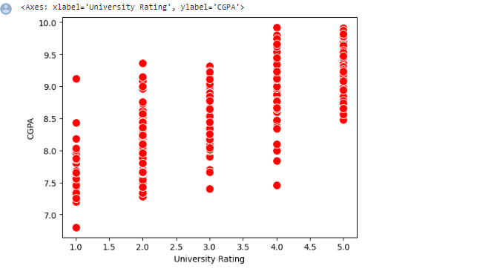

category = ['GRE Score','TOEFL Score','University Rating','SOP','LOR','CGPA','Research','Chance of Admit']

color = ['Yellowgreen','gold','lightskyblue','pink','red','purple','orange','gray']

start = True

for i in np.arange(4):

     fig = plt.figure(figsize=(14,8))

     plt.subplot2grid((4,2),(i,0))

     data[category[2*i+1]].hist(color=color[2*i],bins=10)

     plt.title(category[2*i])

     plt.subplot2grid((4,2),(i,1))

     data[category[2*i+1]].hist(color=color[2*i+1],bins=10)

     plt.title(category[2*i+1])

plt.subplots_adjust(hspace = 0.7, wspace = 0.2)

plt.show()

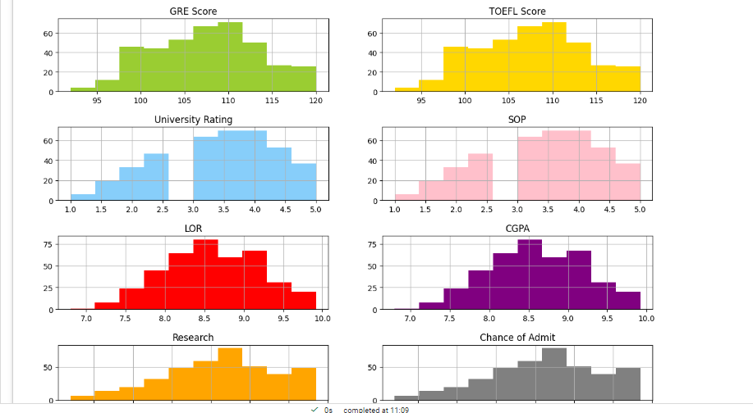

from sklearn.preprocessing import MinMaxScaler

sc = MinMaxScaler()

x=data.iloc[:,0:7].values

x

y=data.iloc[:,7:].values

y

array([[1. , 0.92], [1. , 0.76], [1. , 0.72], [1. , 0.8 ], [0. , 0.65], [1. , 0.9 ], [1. , 0.75], [0. , 0.68], [0. , 0.5 ], [0. , 0.45], [1. , 0.52], [1. , 0.84], [1. , 0.78], [1. , 0.62], [1. , 0.61], [0. , 0.54], [0. , 0.66], [1. , 0.65], [0. , 0.63], [0. , 0.62], [1. , 0.64], [0. , 0.7 ], [1. , 0.94], [1. , 0.95], [1. , 0.97], [1. , 0.94], [0. , 0.76], [1. , 0.44], [0. , 0.46], [0. , 0.54], [1. , 0.65], [1. , 0.74], [1. , 0.91], [1. , 0.9 ], [1. , 0.94], [1. , 0.88], [0. , 0.64], [0. , 0.58], [0. , 0.52], [0. , 0.48], [1. , 0.46], [1. , 0.49], [1. , 0.53], [0. , 0.87], [1. , 0.91], [1. , 0.88], [1. , 0.86], [0. , 0.89], [1. , 0.82], [1. , 0.78], [1. , 0.76], [1. , 0.56], [1. , 0.78], [1. , 0.72], [0. , 0.7 ], [0. , 0.64], [0. , 0.64], [0. , 0.46], [1. , 0.36], [0. , 0.42], [0. , 0.48], [0. , 0.47], [1. , 0.54], [1. , 0.56], [0. , 0.52], [0. , 0.55], [0. , 0.61], [1. , 0.57], [1. , 0.68], [1. , 0.78], [1. , 0.94], [1. , 0.96], [1. , 0.93], [1. , 0.84], [0. , 0.74], [1. , 0.72], [1. , 0.74], [0. , 0.64], [1. , 0.44], [0. , 0.46], [1. , 0.5 ], [1. , 0.96], [1. , 0.92], [1. , 0.92], [1. , 0.94], [0. , 0.76], [0. , 0.72], [0. , 0.66], [0. , 0.64], [1. , 0.74], [1. , 0.64], [0. , 0.38], [0. , 0.34], [1. , 0.44], [0. , 0.36], [0. , 0.42], [0. , 0.48], [1. , 0.86], [1. , 0.9 ], [1. , 0.79], [1. , 0.71], [0. , 0.64], [0. , 0.62], [0. , 0.57], [1. , 0.74], [1. , 0.69], [1. , 0.87], [1. , 0.91], [1. , 0.93], [0. , 0.68], [0. , 0.61], [1. , 0.69], [1. , 0.62], [0. , 0.72], [1. , 0.59], [1. , 0.66], [0. , 0.56], [0. , 0.45], [0. , 0.47], [1. , 0.71], [1. , 0.94], [1. , 0.94], [0. , 0.57], [0. , 0.61], [0. , 0.57], [1. , 0.64], [1. , 0.85], [1. , 0.78], [1. , 0.84], [1. , 0.92], [1. , 0.96], [0. , 0.77], [0. , 0.71], [0. , 0.79], [1. , 0.89], [1. , 0.82], [0. , 0.76], [1. , 0.71], [1. , 0.8 ], [0. , 0.78], [1. , 0.84], [1. , 0.9 ], [1. , 0.92], [1. , 0.97], [1. , 0.8 ], [1. , 0.81], [0. , 0.75], [1. , 0.83], [1. , 0.96], [1. , 0.79], [1. , 0.93], [1. , 0.94], [1. , 0.86], [0. , 0.79], [0. , 0.8 ], [0. , 0.77], [0. , 0.7 ], [0. , 0.65], [0. , 0.61], [0. , 0.52], [0. , 0.57], [0. , 0.53], [0. , 0.67], [0. , 0.68], [1. , 0.81], [0. , 0.78], [0. , 0.65], [0. , 0.64], [1. , 0.64], [0. , 0.65], [1. , 0.68], [1. , 0.89], [1. , 0.86], [1. , 0.89], [1. , 0.87], [1. , 0.85], [1. , 0.9 ], [0. , 0.82], [0. , 0.72], [0. , 0.73], [0. , 0.71], [0. , 0.71], [0. , 0.68], [0. , 0.75], [0. , 0.72], [1. , 0.89], [1. , 0.84], [1. , 0.93], [1. , 0.93], [1. , 0.88], [1. , 0.9 ], [1. , 0.87], [1. , 0.86], [1. , 0.94], [0. , 0.77], [1. , 0.78], [0. , 0.73], [0. , 0.73], [0. , 0.7 ], [0. , 0.72], [1. , 0.73], [1. , 0.72], [1. , 0.97], [1. , 0.97], [0. , 0.69], [0. , 0.57], [0. , 0.63], [1. , 0.66], [0. , 0.64], [1. , 0.68], [1. , 0.79], [1. , 0.82], [1. , 0.95], [1. , 0.96], [1. , 0.94], [1. , 0.93], [1. , 0.91], [1. , 0.85], [1. , 0.84], [0. , 0.74], [0. , 0.76], [0. , 0.75], [0. , 0.76], [0. , 0.71], [0. , 0.67], [0. , 0.61], [0. , 0.63], [0. , 0.64], [0. , 0.71], [1. , 0.82], [0. , 0.73], [1. , 0.74], [0. , 0.69], [0. , 0.64], [1. , 0.91], [1. , 0.88], [1. , 0.85], [1. , 0.86], [0. , 0.7 ], [0. , 0.59], [0. , 0.6 ], [0. , 0.65], [1. , 0.7 ], [1. , 0.76], [0. , 0.63], [1. , 0.81], [0. , 0.72], [0. , 0.71], [1. , 0.8 ], [1. , 0.77], [1. , 0.74], [0. , 0.7 ], [1. , 0.71], [1. , 0.93], [0. , 0.85], [0. , 0.79], [0. , 0.76], [1. , 0.78], [1. , 0.77], [1. , 0.9 ], [1. , 0.87], [0. , 0.71], [1. , 0.7 ], [1. , 0.7 ], [1. , 0.75], [0. , 0.71], [0. , 0.72], [1. , 0.73], [0. , 0.83], [0. , 0.77], [1. , 0.72], [0. , 0.54], [0. , 0.49], [1. , 0.52], [0. , 0.58], [1. , 0.78], [1. , 0.89], [0. , 0.7 ], [0. , 0.66], [0. , 0.67], [1. , 0.68], [1. , 0.8 ], [1. , 0.81], [1. , 0.8 ], [1. , 0.94], [1. , 0.93], [1. , 0.92], [1. , 0.89], [0. , 0.82], [0. , 0.79], [0. , 0.58], [0. , 0.56], [0. , 0.56], [1. , 0.64], [1. , 0.61], [0. , 0.68], [0. , 0.76], [0. , 0.86], [1. , 0.9 ], [0. , 0.71], [0. , 0.62], [0. , 0.66], [1. , 0.65], [1. , 0.73], [0. , 0.62], [1. , 0.74], [1. , 0.79], [1. , 0.8 ], [0. , 0.69], [0. , 0.7 ], [1. , 0.76], [1. , 0.84], [1. , 0.78], [0. , 0.67], [0. , 0.66], [0. , 0.65], [0. , 0.54], [0. , 0.58], [1. , 0.79], [1. , 0.8 ], [1. , 0.75], [1. , 0.73], [0. , 0.72], [0. , 0.62], [0. , 0.67], [1. , 0.81], [0. , 0.63], [0. , 0.69], [1. , 0.8 ], [0. , 0.43], [1. , 0.8 ], [1. , 0.73], [1. , 0.75], [1. , 0.71], [1. , 0.73], [1. , 0.83], [0. , 0.72], [1. , 0.94], [1. , 0.81], [1. , 0.81], [1. , 0.75], [1. , 0.79], [0. , 0.58], [0. , 0.59], [0. , 0.47], [0. , 0.49], [0. , 0.47], [0. , 0.42], [0. , 0.57], [0. , 0.62], [1. , 0.74], [1. , 0.73], [1. , 0.64], [0. , 0.63], [0. , 0.59], [0. , 0.73], [1. , 0.79], [1. , 0.68], [0. , 0.7 ], [0. , 0.81], [1. , 0.85], [1. , 0.93], [1. , 0.91], [0. , 0.69], [1. , 0.77], [1. , 0.86], [1. , 0.74], [0. , 0.57], [0. , 0.51], [1. , 0.67], [0. , 0.72], [1. , 0.89], [1. , 0.95], [1. , 0.79], [0. , 0.39], [0. , 0.38], [0. , 0.34], [0. , 0.47], [0. , 0.56], [1. , 0.71], [1. , 0.78], [1. , 0.73], [1. , 0.82], [0. , 0.62], [1. , 0.96], [1. , 0.96], [0. , 0.46], [0. , 0.53], [0. , 0.49], [1. , 0.76], [0. , 0.64], [0. , 0.71], [1. , 0.84], [0. , 0.77], [1. , 0.89], [1. , 0.82], [1. , 0.84], [1. , 0.91], [0. , 0.67], [1. , 0.95]])

x=sc.fit_transform(x)

x

array([[0. , 0.94 , 0.92857143, ..., 0.875 , 0.875 , 0.91346154], [0.00250627, 0.68 , 0.53571429, ..., 0.75 , 0.875 , 0.66346154], [0.00501253, 0.52 , 0.42857143, ..., 0.5 , 0.625 , 0.38461538], ..., [0.99498747, 0.8 , 0.85714286, ..., 1. , 0.875 , 0.84935897], [0.99749373, 0.44 , 0.39285714, ..., 0.625 , 0.75 , 0.63461538], [1. , 0.86 , 0.89285714, ..., 1. , 0.75 , 0.91666667]])

from sklearn.model_selection import train_test_split

x_train, x_test, y_train, y_test = train_test_split(x,y, test_size=0.30,random_state=101)

y_train=(y_train>0.5)

y_train

y_test=(y_test>0.5)

Milestone 4

from sklearn.linear_model import LogisticRegression

cls =LogisticRegression(random_state =0)

lr=cls.fit(x_train, y_train.argmax(axis=1))

y_pred =lr.predict(x_test)

y_pred

array([1, 1, 1, 1, 1, 0, 0, 1, 0, 0, 0, 0, 0, 0, 1, 0, 0, 0, 1, 0, 1, 0, 0, 0, 1, 0, 0, 0, 1, 0, 0, 0, 1, 0, 1, 0, 1, 0, 0, 0, 0, 0, 0, 0, 0, 0, 0, 0, 1, 0, 1, 0, 0, 1, 0, 0, 0, 1, 0, 1, 1, 0, 0, 0, 0, 1, 0, 1, 1, 0, 1, 0, 0, 0, 0, 0, 0, 0, 0, 0, 0, 0, 1, 0, 0, 0, 0, 0, 0, 0, 0, 0, 0, 0, 1, 0, 1, 0, 1, 0, 0, 0, 0, 0, 1, 0, 1, 0, 0, 0, 0, 0, 1, 0, 0, 0, 0, 0, 0, 0])

import tensorflow as tf

from tensorflow import keras

from tensorflow.keras.layers import Dense, Activation, Dropout

from tensorflow.keras.optimizers import Adam

model=keras.Sequential()

model.add(Dense(7,activation ='relu',input_dim=7))

model.add(Dense(7,activation='relu'))

model.add(Dense(1,activation='linear'))

model.summary(

Model: "sequential"

_________________________________________________________________

Layer (type) Output Shape Param #

=================================================================

dense (Dense) (None, 7) 56

dense_1 (Dense) (None, 7) 56

dense_2 (Dense) (None, 1) 8

=================================================================

Total params: 120

Trainable params: 120

Non-trainable params: 0

_ model.compile(loss = 'binary_crossentropy', optimizer = 'adam',metrics=['accuracy'])

model.fit(x_train, y_train, batch_size = 20, epochs = 100)

Epoch 1/100

14/14 [==============================] - 1s 2ms/step - loss: 6.0067 - accuracy: 0.2411

Epoch 2/100

14/14 [==============================] - 0s 1ms/step - loss: 2.6148 - accuracy: 0.2411

Epoch 3/100

14/14 [==============================] - 0s 1ms/step - loss: 1.6927 - accuracy: 0.2411

Epoch 4/100

14/14 [==============================] - 0s 1ms/step - loss: 1.3205 - accuracy: 0.2411

Epoch 5/100

14/14 [==============================] - 0s 1ms/step - loss: 1.1105 - accuracy: 0.2446

Epoch 6/100

14/14 [==============================] - 0s 2ms/step - loss: 0.9750 - accuracy: 0.2732

Epoch 7/100

14/14 [==============================] - 0s 1ms/step - loss: 0.8954 - accuracy: 0.3411

Epoch 8/100

14/14 [==============================] - 0s 1ms/step - loss: 0.7938 - accuracy: 0.4482

Epoch 9/100

14/14 [==============================] - 0s 1ms/step - loss: 0.7379 - accuracy: 0.5161

Epoch 10/100

14/14 [==============================] - 0s 1ms/step - loss: 0.6943 - accuracy: 0.5589

Epoch 11/100

14/14 [==============================] - 0s 1ms/step - loss: 0.6547 - accuracy: 0.6196

Epoch 12/100

14/14 [==============================] - 0s 1ms/step - loss: 0.6195 - accuracy: 0.6696

Epoch 13/100

14/14 [==============================] - 0s 1ms/step - loss: 0.5861 - accuracy: 0.7089

Epoch 14/100

14/14 [==============================] - 0s 1ms/step - loss: 0.5561 - accuracy: 0.7339

Epoch 15/100

14/14 [==============================] - 0s 2ms/step - loss: 0.5364 - accuracy: 0.7339

Epoch 16/100

14/14 [==============================] - 0s 2ms/step - loss: 0.5239 - accuracy: 0.7554

Epoch 17/100

14/14 [==============================] - 0s 1ms/step - loss: 0.5187 - accuracy: 0.7589

Epoch 18/100

14/14 [==============================] - 0s 1ms/step - loss: 0.5122 - accuracy: 0.7589

Epoch 19/100

14/14 [==============================] - 0s 2ms/step - loss: 0.5068 - accuracy: 0.7589

Epoch 20/100

14/14 [==============================] - 0s 1ms/step - loss: 0.5009 - accuracy: 0.7589

Epoch 21/100

14/14 [==============================] - 0s 1ms/step - loss: 0.4953 - accuracy: 0.7625

Epoch 22/100

14/14 [==============================] - 0s 1ms/step - loss: 0.4908 - accuracy: 0.7625

Epoch 23/100

14/14 [==============================] - 0s 1ms/step - loss: 0.4866 - accuracy: 0.7625

Epoch 24/100

14/14 [==============================] - 0s 1ms/step - loss: 0.4820 - accuracy: 0.7625

Epoch 25/100

14/14 [==============================] - 0s 1ms/step - loss: 0.4780 - accuracy: 0.7625

Epoch 26/100

14/14 [==============================] - 0s 1ms/step - loss: 0.4745 - accuracy: 0.7696

Epoch 27/100

14/14 [==============================] - 0s 1ms/step - loss: 0.4714 - accuracy: 0.7696

Epoch 28/100

14/14 [==============================] - 0s 1ms/step - loss: 0.4687 - accuracy: 0.7732

Epoch 29/100

14/14 [==============================] - 0s 1ms/step - loss: 0.4661 - accuracy: 0.7732

Epoch 30/100

14/14 [==============================] - 0s 1ms/step - loss: 0.4643 - accuracy: 0.7732

Epoch 31/100

14/14 [==============================] - 0s 2ms/step - loss: 0.4620 - accuracy: 0.7696

Epoch 32/100

14/14 [==============================] - 0s 1ms/step - loss: 0.4609 - accuracy: 0.7696

Epoch 33/100

14/14 [==============================] - 0s 1ms/step - loss: 0.4589 - accuracy: 0.7696

Epoch 34/100

14/14 [==============================] - 0s 2ms/step - loss: 0.4578 - accuracy: 0.7696

Epoch 35/100

14/14 [==============================] - 0s 1ms/step - loss: 0.4570 - accuracy: 0.7696

Epoch 36/100

14/14 [==============================] - 0s 1ms/step - loss: 0.4560 - accuracy: 0.7696

Epoch 37/100

14/14 [==============================] - 0s 2ms/step - loss: 0.4549 - accuracy: 0.7696

Epoch 38/100

14/14 [==============================] - 0s 1ms/step - loss: 0.4543 - accuracy: 0.7696

Epoch 39/100

14/14 [==============================] - 0s 1ms/step - loss: 0.4537 - accuracy: 0.7696

Epoch 40/100

14/14 [==============================] - 0s 1ms/step - loss: 0.4529 - accuracy: 0.7696

Epoch 41/100

14/14 [==============================] - 0s 1ms/step - loss: 0.4526 - accuracy: 0.7696

Epoch 42/100

14/14 [==============================] - 0s 1ms/step - loss: 0.4516 - accuracy: 0.7696

Epoch 43/100

14/14 [==============================] - 0s 1ms/step - loss: 0.4508 - accuracy: 0.7696

Epoch 44/100

14/14 [==============================] - 0s 1ms/step - loss: 0.4506 - accuracy: 0.7696

Epoch 45/100

14/14 [==============================] - 0s 1ms/step - loss: 0.4501 - accuracy: 0.7696

Epoch 46/100

14/14 [==============================] - 0s 1ms/step - loss: 0.4497 - accuracy: 0.7696

Epoch 47/100

14/14 [==============================] - 0s 1ms/step - loss: 0.4490 - accuracy: 0.7696

Epoch 48/100

14/14 [==============================] - 0s 1ms/step - loss: 0.4485 - accuracy: 0.7696

Epoch 49/100

14/14 [==============================] - 0s 1ms/step - loss: 0.4481 - accuracy: 0.7696

Epoch 50/100

14/14 [==============================] - 0s 1ms/step - loss: 0.4483 - accuracy: 0.7696

Epoch 51/100

14/14 [==============================] - 0s 1ms/step - loss: 0.4473 - accuracy: 0.7696

Epoch 52/100

14/14 [==============================] - 0s 1ms/step - loss: 0.4470 - accuracy: 0.7696

Epoch 53/100

14/14 [==============================] - 0s 1ms/step - loss: 0.4464 - accuracy: 0.7696

Epoch 54/100

14/14 [==============================] - 0s 1ms/step - loss: 0.4461 - accuracy: 0.7696

Epoch 55/100

14/14 [==============================] - 0s 1ms/step - loss: 0.4458 - accuracy: 0.7696

Epoch 56/100

14/14 [==============================] - 0s 1ms/step - loss: 0.4457 - accuracy: 0.7696

Epoch 57/100

14/14 [==============================] - 0s 2ms/step - loss: 0.4446 - accuracy: 0.7696

Epoch 58/100

14/14 [==============================] - 0s 2ms/step - loss: 0.4453 - accuracy: 0.7696

Epoch 59/100

14/14 [==============================] - 0s 1ms/step - loss: 0.4444 - accuracy: 0.7696

Epoch 60/100

14/14 [==============================] - 0s 1ms/step - loss: 0.4439 - accuracy: 0.7732

Epoch 61/100

14/14 [==============================] - 0s 1ms/step - loss: 0.4446 - accuracy: 0.7732

Epoch 62/100

14/14 [==============================] - 0s 1ms/step - loss: 0.4430 - accuracy: 0.7732

Epoch 63/100

14/14 [==============================] - 0s 1ms/step - loss: 0.4427 - accuracy: 0.7732

Epoch 64/100

14/14 [==============================] - 0s 2ms/step - loss: 0.4422 - accuracy: 0.7804

Epoch 65/100

14/14 [==============================] - 0s 1ms/step - loss: 0.4420 - accuracy: 0.7804

Epoch 66/100

14/14 [==============================] - 0s 1ms/step - loss: 0.4414 - accuracy: 0.7804

Epoch 67/100

14/14 [==============================] - 0s 1ms/step - loss: 0.4414 - accuracy: 0.7804

Epoch 68/100

14/14 [==============================] - 0s 1ms/step - loss: 0.4416 - accuracy: 0.7768

Epoch 69/100

14/14 [==============================] - 0s 1ms/step - loss: 0.4403 - accuracy: 0.7839

Epoch 70/100

14/14 [==============================] - 0s 1ms/step - loss: 0.4404 - accuracy: 0.7839

Epoch 71/100

14/14 [==============================] - 0s 1ms/step - loss: 0.4401 - accuracy: 0.7875

Epoch 72/100

14/14 [==============================] - 0s 2ms/step - loss: 0.4404 - accuracy: 0.7839

Epoch 73/100

14/14 [==============================] - 0s 1ms/step - loss: 0.4406 - accuracy: 0.7875

Epoch 74/100

14/14 [==============================] - 0s 1ms/step - loss: 0.4388 - accuracy: 0.7875

Epoch 75/100

14/14 [==============================] - 0s 1ms/step - loss: 0.4387 - accuracy: 0.7875

Epoch 76/100

14/14 [==============================] - 0s 2ms/step - loss: 0.4387 - accuracy: 0.7875

Epoch 77/100

14/14 [==============================] - 0s 2ms/step - loss: 0.4380 - accuracy: 0.7875

Epoch 78/100

14/14 [==============================] - 0s 2ms/step - loss: 0.4380 - accuracy: 0.7875

Epoch 79/100

14/14 [==============================] - 0s 1ms/step - loss: 0.4380 - accuracy: 0.7875

Epoch 80/100

14/14 [==============================] - 0s 2ms/step - loss: 0.4369 - accuracy: 0.7875

Epoch 81/100

14/14 [==============================] - 0s 2ms/step - loss: 0.4370 - accuracy: 0.7875

Epoch 82/100

14/14 [==============================] - 0s 1ms/step - loss: 0.4366 - accuracy: 0.7875

Epoch 83/100

14/14 [==============================] - 0s 1ms/step - loss: 0.4362 - accuracy: 0.7875

Epoch 84/100

14/14 [==============================] - 0s 1ms/step - loss: 0.4358 - accuracy: 0.7875

Epoch 85/100

14/14 [==============================] - 0s 2ms/step - loss: 0.4354 - accuracy: 0.7875

Epoch 86/100

14/14 [==============================] - 0s 1ms/step - loss: 0.4352 - accuracy: 0.7875

Epoch 87/100

14/14 [==============================] - 0s 1ms/step - loss: 0.4350 - accuracy: 0.7875

Epoch 88/100

14/14 [==============================] - 0s 1ms/step - loss: 0.4353 - accuracy: 0.7875

Epoch 89/100

14/14 [==============================] - 0s 2ms/step - loss: 0.4344 - accuracy: 0.7875

Epoch 90/100

14/14 [==============================] - 0s 2ms/step - loss: 0.4344 - accuracy: 0.7875

Epoch 91/100

14/14 [==============================] - 0s 2ms/step - loss: 0.4336 - accuracy: 0.7875

Epoch 92/100

14/14 [==============================] - 0s 1ms/step - loss: 0.4334 - accuracy: 0.7875

Epoch 93/100

14/14 [==============================] - 0s 1ms/step - loss: 0.4336 - accuracy: 0.7875

Epoch 94/100

14/14 [==============================] - 0s 1ms/step - loss: 0.4331 - accuracy: 0.7875

Epoch 95/100

14/14 [==============================] - 0s 2ms/step - loss: 0.4326 - accuracy: 0.7875

Epoch 96/100

14/14 [==============================] - 0s 1ms/step - loss: 0.4323 - accuracy: 0.7875

Epoch 97/100

14/14 [==============================] - 0s 1ms/step - loss: 0.4328 - accuracy: 0.7875

Epoch 98/100

14/14 [==============================] - 0s 1ms/step - loss: 0.4325 - accuracy: 0.7875

Epoch 99/100

14/14 [==============================] - 0s 1ms/step - loss: 0.4330 - accuracy: 0.7875

Epoch 100/100

14/14 [==============================] - 0s 1ms/step - loss: 0.4319 - accuracy: 0.7875

<keras.callbacks.History at 0x7f34116ef580>

from sklearn.metrics import accuracy_score

train_prediction = model.predict(x_train)

print(train_prediction)

[[0.98496866]

[0.9571771 ]

[0.80146414]

[0.965022 ]

[0.55910033]

[0.85745984]

[1.0377476 ]

[0.83251894]

[0.6962016 ]

[0.79688525]

[1.0734332 ]

[0.77326494]

[1.0965585 ]

[0.7395618 ]

[0.6357908 ]

[0.1542776 ]

[0.51768774]

[0.5439081 ]

[0.8596706 ]

[0.7208419 ]

[0.6097973 ]

[0.8953505 ]

[0.58150846]

[0.6901734 ]

[0.94987035]

[0.8301814 ]

[1.0458825 ]

[0.8461155 ]

[0.5308199 ]

[0.7637013 ]

[0.789408 ]

[0.43426216]

[0.8700549 ]

[0.29839173]

[0.6699857 ]

[0.9496789 ]

[1.084537 ]

[0.6412462 ]

[1.0814015 ]

[0.2712986 ]

[0.7543817 ]

[0.735067 ]

[1.053178 ]

[0.60264385]

[0.5954556 ]

[0.83751976]

[0.6362673 ]

[0.87383157]

[0.5816313 ]

[0.7048959 ]

[0.92944294]

[0.7409356 ]

[0.35220125]

[0.89482737]

[0.73396957]

[0.9736438 ]

[0.266265 ]

[0.72058994]

[0.9379014 ]

[0.6628741 ]

[0.93297327]

[1.0781159 ]

[0.8568954 ]

[0.6965215 ]

[0.49964893]

[0.89667284]

[0.88260835]

[0.3743728 ]

[0.7805429 ]

[0.4019034 ]

[0.84943855]

[0.37936562]

[0.8025182 ]

[0.6164419 ]

[0.94514555]

[0.83763266]

[0.32469466]

[0.9849853 ]

[0.8631807 ]

[1.097511 ]

[0.7619977 ]

[0.8508456 ]

[0.42793277]

[0.591111 ]

[0.9175422 ]

[0.8403404 ]

[0.657011 ]

[0.92005396]

[0.8002535 ]

[0.6949558 ]

[0.7924662 ]

[0.7846341 ]

[0.73634875]

[1.0125213 ]

[1.0447965 ]

[0.6777717 ]

[0.3866413 ]

[0.515978 ]

[0.99782205]

[0.6182346 ]

[0.7756186 ]

[0.6113335 ]

[0.53804594]

[1.0594791 ]

[0.54643184]

[0.75097567]

[0.62937826]

[0.66837424]

[0.6770849 ]

[0.51260436]

[1.1729188 ]

[0.85702604]

[0.6014111 ]

[0.7687463 ]

[0.90492475]

[0.60149944]

[1.0137875 ]

[1.0361652 ]

[0.52606326]

[0.90284127]

[0.6947048 ]

[0.5269238 ]

[0.15767097]

[0.8066671 ]

[1.2186788 ]

[0.5629144 ]

[0.5450496 ]

[0.65710735]

[0.9119291 ]

[0.9766147 ]

[1.0653049 ]

[0.55267733]

[0.71263963]

[0.616312 ]

[0.7005726 ]

[0.5719438 ]

[0.9350637 ]

[1.0638705 ]

[0.9685313 ]

[0.73248917]

[0.539042 ]

[0.5818577 ]

[0.9765147 ]

[0.81416744]

[1.033384 ]

[0.7078411 ]

[0.884723 ]

[0.9717945 ]

[1.0899688 ]

[0.57816917]

[0.71278054]

[0.6716515 ]

[0.7728167 ]

[0.33091214]

[1.0761378 ]

[0.70570946]

[1.0651208 ]

[0.48765847]

[0.95538014]

[0.57107425]

[0.858404 ]

[0.73409504]

[0.61741173]

[0.6285652 ]

[0.8487037 ]

[1.019117 ]

[0.8489926 ]

[1.0355043 ]

[0.91691786]

[0.6107283 ]

[0.947842 ]

[0.5982895 ]

[0.9690092 ]

[0.70689905]

[0.89034253]

[1.213513 ]

[0.3362929 ]

[1.1450516 ]

[0.7505639 ]

[0.4612304 ]

[0.8506809 ]

[0.99943846]

[1.0385426 ]

[0.6657194 ]

[0.7262759 ]

[0.9829498 ]

[0.8092816 ]

[0.7789211 ]

[0.93298995]

[0.662073 ]

[0.65287036]

[0.7774873 ]

[0.6254941 ]

[1.095521 ]

[0.7915138 ]

[0.91773546]

[0.5637762 ]

[1.0923911 ]

[0.53991896]

[0.7721362 ]

[0.8164659 ]

[0.6353512 ]

[0.873059 ]

[0.68728703]

[0.37044337]

[0.80692387]

[0.62983197]

[1.1498067 ]

[0.49032775]

[0.89043 ]

[0.52473193]

[1.0106409 ]

[0.7743693 ]

[0.9806146 ]

[0.87442386]

[0.84296715]

[0.79575884]

[1.084264 ]

[0.6236583 ]

[0.7959385 ]

[0.5258752 ]

[1.1642236 ]

[0.8644466 ]

[1.091092 ]

[0.9496991 ]

[1.0194218 ]

[0.85202825]

[0.344368 ]

[0.84290314]

[0.65277493]

[0.95231265]

[0.5832234 ]

[0.65303475]

[0.43989885]

[0.46276814]

[0.5471243 ]

[0.6755098 ]

[0.8296624 ]

[0.5426245 ]

[0.9546388 ]

[1.1339033 ]

[0.838018 ]

[0.95165914]

[0.57520014]

[0.78762686]

[0.3375264 ]

[0.7752656 ]

[0.58471245]

[0.89770544]

[0.6183302 ]

[0.70314705]

[0.79798245]

[0.9093797 ]

[0.8239428 ]

[0.96383417]

[0.9596824 ]

[0.48175305]

[0.36311617]

[0.9635995 ]

[0.85254693]

[0.84782076]

[0.86142606]

[0.77982193]

[1.0285406 ]

[0.9005086 ]

[0.64389175]

[0.94345844]

[0.79196835]

[0.34705245]

[0.9556226 ]

[0.9505243 ]

[0.71763664]

[0.65486616]

[0.6363946 ]

[0.7078728 ]

[0.74412775]

[0.51595145]

[1.1060307 ]

[0.8986826 ]

[0.88185793]]

train_acc = model.evaluate(x_train, y_train, verbose=0)[1]

print(train_acc)

0.7875000238418579

test_acc = model.evaluate(x_test, y_test, verbose=0)[1]

print(test_acc)

0.7041666507720947

pred=model.predict(x_test)

pred = (pred>0.5)

pred

4/4 [==============================] - 0s 2ms/step

array([[ True],

[ True],

[ True],

[ True],

[ True],

[ True],

[ True],

[False],

[ True],

[ True],

[ True],

[ True],

[ True],

[ True],

[ True],

[ True],

[ True],

[ True],

[False],

[ True],

[ True],

[ True],

[ True],

[ True],

[False],

[ True],

[ True],

[ True],

[False],

[ True],

[ True],

[ True],

[False],

[ True],

[False],

[False],

[ True],

[ True],

[ True],

[ True],

[ True],

[ True],

[ True],

[ True],

[ True],

[ True],

[ True],

[ True],

[False],

[ True],

[ True],

[ True],

[ True],

[False],

[ True],

[ True],

[ True],

[False],

[ True],

[False],

[False],

[ True],

[ True],

[ True],

[ True],

[ True],

[ True],

[ True],

[False],

[ True],

[False],

[ True],

[ True],

[ True],

[ True],

[ True],

[ True],

[ True],

[ True],

[ True],

[ True],

[ True],

[ True],

[ True],

[ True],

[ True],

[ True],

[ True],

[ True],

[ True],

[ True],

[ True],

[ True],

[ True],

[False],

[ True],

[False],

[ True],

[ True],

[ True],

[ True],

[False],

[ True],

[ True],

[ True],

[ True],

[False],

[ True],

[ True],

[ True],

[ True],

[ True],

[ True],

[ True],

[ True],

[ True],

[ True],

[ True],

[ True],

[ True]])

y_pred = y_pred.astype

y_pred

y_test = y_test.astype(int)

y_test

array([[0, 1], [0, 1], [1, 1], [0, 1], [1, 1], [1, 1], [0, 1], [0, 0], [1, 1], [0, 1], [0, 1], [1, 1], [1, 1], [1, 1], [0, 0], [0, 1], [1, 1], [0, 1], [0, 1], [0, 1], [0, 1], [0, 1], [1, 1], [1, 1], [0, 1], [1, 1], [0, 1], [1, 1], [0, 1], [1, 1], [1, 1], [1, 1], [0, 0], [1, 1], [0, 1], [0, 1], [0, 1], [0, 1], [0, 1], [0, 1], [1, 1], [0, 1], [1, 1], [1, 1], [1, 1], [1, 1], [0, 1], [0, 1], [0, 1], [1, 1], [0, 1], [1, 1], [1, 1], [0, 1], [1, 1], [1, 1], [0, 1], [1, 1], [0, 1], [0, 0], [0, 0], [1, 1], [0, 1], [0, 0], [0, 1], [0, 1], [0, 1], [1, 1], [0, 0], [0, 1], [0, 1], [0, 1], [1, 1], [0, 1], [0, 1], [1, 1], [1, 1], [1, 1], [0, 1], [0, 1], [1, 1], [1, 1], [0, 0], [1, 1], [1, 1], [1, 1], [0, 1], [1, 1], [1, 1], [0, 1], [0, 1], [0, 1], [1, 1], [1, 1], [0, 1], [0, 1], [1, 1], [1, 1], [0, 1], [0, 1], [0, 0], [0, 0], [0, 1], [0, 0], [0, 1], [1, 1], [0, 0], [1, 1], [1, 1], [1, 1], [0, 1], [0, 1], [0, 1], [0, 1], [1, 1], [0, 1], [0, 1], [1, 1], [1, 1], [0, 1]])

Milestone 5

def logreg(x_train,x_test,y_train,y_test):

  lr = LogisticRegression(random_state=0)

  lr.fit(x_train,y_train)

  y_lr_tr = lr.predict(x_train)

  print(accuracy_score(y_lr_tr,y_train))

  ypred_lr = lr.predict(x_test)

  print(accuracy_score(y_lr_tr,y_train))

  print("***Logistic Regression***")

  print("Confusion_Matrix")

  print("Classification Report")

  print(classification_report(y_test,ypred_lr))

from sklearn.metrics import accuracy_score,recall_score,roc_aue_score,confusion_matrix

print("\nAccuracy score: %f" %(accuracy_score(y_test,y_pred) * 100))

print("Recall score : %f" % (recall_score(y_test,y_pred) * 100))

print("ROC score : %f\n" %(roc_auc_score(y_test,y_pred) * 100))

print(confusion_matrix(y_test,y_pred))

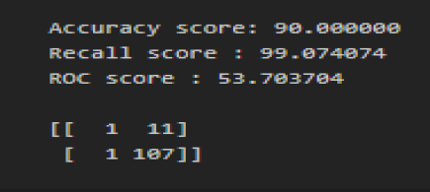

from sklearn.metrics import accuracy_score,recall_score,roc_auc_score,confusion_matrix

print(classification_report(y_train,y_pre

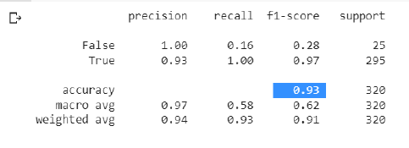

from sklearn.metrics import accuracy_score,recall_score,roc_auc_score,confusion_matrix

print(classification_report(y_test,y_pred))

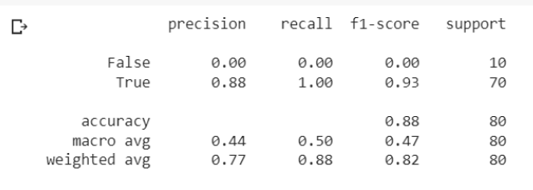

Milestone 6

# save the model in HDF5 fromat

model.save('model.h5')

import numpy as np

from flask import Flask, request, jsonify, render_template

import pickle

app = Flask(__name__)

from tensorflow.keras.models import load_model

model = load_model('model.h5')

@app.route('/')

def home():

  return render_template('Demo2.html')